POLARIZATION
Table 1 shows the theoretical ratio of power transmitted between antennas of different polarization. These ratios are seldom fully achieved due to effects such as reflection, refraction, and other wave interactions, so some practical ratios are also included.
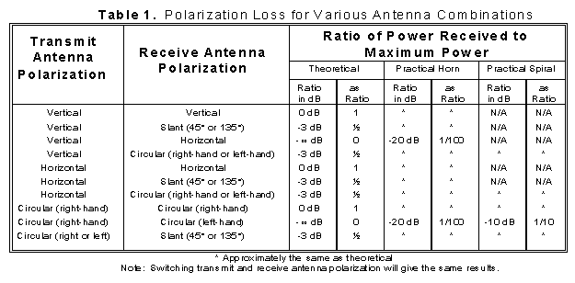
The polarization of an electromagnetic wave is defined as the orientation of the electric field vector. Recall that the electric field vector is perpendicular to both the direction of travel and the magnetic field vector. The polarization is described by the geometric figure traced by the electric field vector upon a stationary plane perpendicular to the direction of propagation, as the wave travels through that plane. An electromagnetic wave is frequently composed of (or can be broken down into) two orthogonal components as shown in Figure 1.
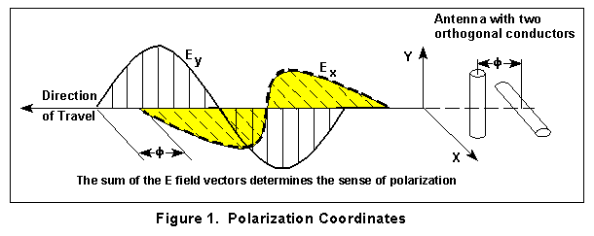
This may be due to the arrangement of power input leads to various points on a flat antenna, or due to an interaction of active elements in an array, or many other reasons. The geometric figure traced by the sum of the electric field vectors over time is, in general, an ellipse as shown in Figure 2.

Under certain conditions the ellipse may collapse into a straight line, in which case the polarization is called linear. In the other extreme, when the two components are of equal magnitude and 90° out of phase, the ellipse will become circular as shown in Figure 3. Thus linear and circular polarization are the two special cases of elliptical polarization. Linear polarization may be further classified as being vertical, horizontal, or slant.
Figure 2 depicts plots of the E field vector while varying the relative amplitude and phase angle of its component parts.
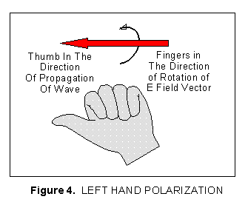
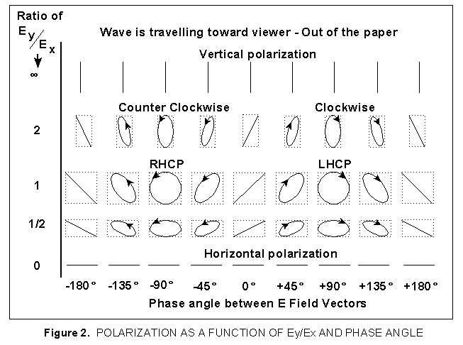
For a linearly polarized antenna, the radiation pattern is taken both for a co-polarized and cross polarized response. The polarization quality is expressed by the ratio of these two responses. The ratio between the responses must typically be great (30 dB or greater) for an application such as cross-polarized jamming. For general applications, the ratio
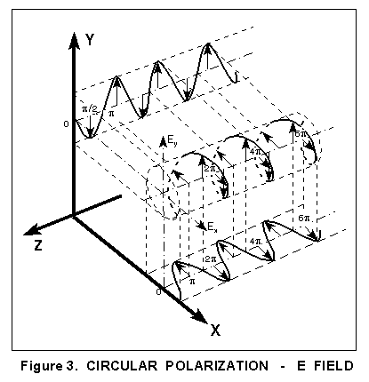

indicates system power loss due to polarization mismatch. For circularly polarizedantennas, radiation patterns are usually taken with a rotating linearly polarized reference antenna. The reference antenna rotates many times while taking measurements around the azimuth of the antenna that is being tested. The resulting antenna pattern is the linear polarized gain with a cyclic ripple. The peak-to-peak value is the axial ratio, and represents the polarization quality for a circular polarized antenna. The typical RWR antenna has a maximum 3 dB axial ratio within 45° of boresight.
For any antenna with an aperture area, as the aperture is rotated, the viewed dimension along the axis remains constant, while the other viewed dimension decreases to zero at 90° rotation. The axial ratio of an antenna will get worse as the antenna is rotated off boresight because the field contribution from the axial component will remain fairly constant and the other orthogonal component will decrease with rotation.
The sense of antenna polarization is defined from a viewer positioned behind an antenna looking in the direction of propagation. The polarization is specified as a transmitting, not receiving antenna regardless of intended use.
We frequently use "hand rules" to describe the sense of polarization. The sense is defined by which hand would be used in order to point that thumb in the direction of propagation and point the fingers of the same hand in the direction of rotation of the E field vector. For example, referring to Figure 4, if your thumb is pointed in the direction of propagation and the rotation is counterclockwise looking in the direction of travel, then you have left hand circular polarization.
Optics people view an aperture from the front and therefore use the opposite reference.
The polarization of a linearly polarized horn antenna can be directly determined by the orientation of the feed probe, which is in the direction of the E-field.
In general, a flat surface or sphere will reflect a linearly polarized wave with the same polarization as received. A horizontally polarized wave may get extended range because of water and land surface reflections, but signal cancellation will probably result in "holes" in coverage. Reflections will reverse the sense of circular polarization.
If the desired antenna is used for receiving a direct transmission as shown in Figure 5 below, the same polarization sense (specified if transmitting) is required for maximum signal reception in this situation. Buy two right-hand or two left-hand circularly polarized antennas for this case. When you procure antennas, remember that the polarization is specified as if transmitting, regardless of intended use.
Wave propagation between two identical antennas is analogous to being able to thread a nut from one bolt to an identical opposite facing bolt.
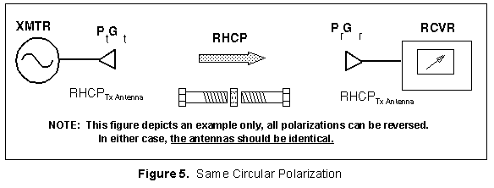
If the desired antenna is used for a receiving a wave with a single or odd number of reflections, such as a bistatic radar where separate antennas are used for transmit and receive as shown in Figure 6, then opposite circularly polarized antennas would be used for maximum signal reception. In this case buy antennas of opposite polarization sense (one left hand and one right hand).
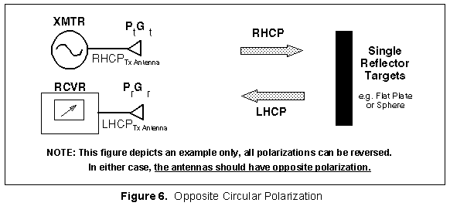
In a corner reflector, waves reflect twice before returning to the receiver as shown in Figure 7, consequently they return with the same sense as they were transmitted. In this case (or any even number of reflections) buy antennas of the same polarization sense.
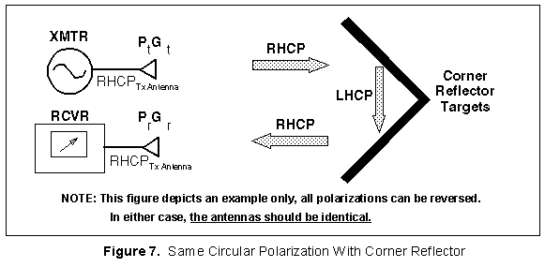
An aircraft acts as both a corner reflector and a "normal" reflector so the return has mixed polarization. Most airborne radars use the same antenna for transmitting and receiving in order to receive the corner reflections and help exclude receipt of reflections from rain (single polarization reversal), however in doing so there is about a 9 dB loss from the ideal receiver case. It should be noted that some return from rain may still appear on radars using a single antenna because of multiple reflections off other raindrops causing additional polarization reversals.

Return to: EW & Radar Handbook Home Page | Table of Contents

